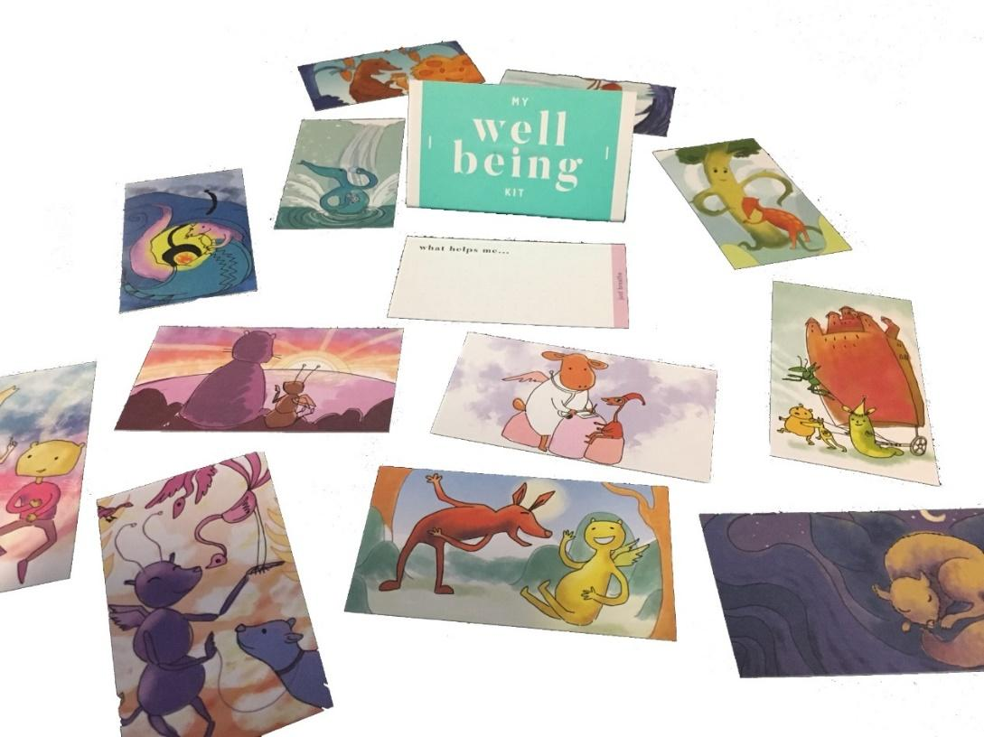

My Wellbeing Kit

Software Requirements Document

|  |  |
| --- | --- |
| Sam Fahey | Project Manager |
| Aiden Vos | Client Liaison |
| Changlai Zhao | Lead Artist/Interfacer |
| William Stephenson | Lead Programmer |
| WenHao Wang | Lead Programmer |
| Weibo Chen | Lead Designer |
| Sa Ma | Lead Designer |

Table of Contents

**1. Introduction** **2**

1.1 Client Overview 2

1.2 Current Situation 2

1.3 Project Outline 3

**2. Users** **3**

**3. Components** **3**

3.1 Wellbeing Cards 4

3.1.1 Flipping (animated) 4

3.1.2 Writing description of feelings on back 5

3.1.3 Editing descriptions 5

3.1.4 Duplicating Existing Cards 5

3.1.5 Favourite Cards 6

3.2 Custom Cards 6

3.2.1 Adding Custom Cards 6

3.2.2 Editing Custom Cards 7

3.3 Journaling System 7

3.3.1 Creation of Journal Entries 7

3.3.2 Editing of Journal Entries 8

3.3.3 Dating of Journal Entries 8

3.3.4 Categorisation of Journal Entries 8

3.3.5 Sort Function 8

3.3.6 Journal Password Lock 9

3.4 Dictionary of Emotions (The Emotional Bank) 9

3.4.1 Tree of Words 10

3.4.2 Descriptor prompt 10

3.5 Helpful Resources 10

3.5.1 Adding Additional Resources 10

3.5.2 Editing Existing Resource Entries 11

3.6 User Interface 11

3.7 Supplementary Components 12

3.7.1 Adding Music 12

3.7.2 User Application Customisation 12

**4. Appendix** **13**

4.1 Glossary of Terms 13

4.2 Existing My Wellbeing Kit Images 14

**5. References** **15**

# 1. Introduction

## 1.1 Client Overview

The client for this project is the Clarence City Council, a local government organisation located in the south of Tasmania. The project will be contributing to the Live Clarence program being run by the Clarence City Council and will work in conjunction with Tasmania’s Department of Health and Human Services. The Live Clarence program is dedicated to the fulfilment of the Community Health and Wellbeing Plan 2013-2018. This plan focuses on spreading information for the community of Clarence regarding health, wellbeing and opportunities to be engaged in the community (Clarence City Council, 2018). The Live Clarence team have been responsible for a number of community programs and events, one of which is the Wellbeing Kit which will be the focus of this project.

## 1.2 Current Situation

My Wellbeing Kit is a set of thirteen beautifully illustrated cards that focus on the simple ways users can build resilience and improve their health and wellbeing when faced with challenging times. The front of each card has unique thematic artwork relating to different situations of mental unrest that the user may find themselves in. On the back of each card is the the title of the card and space for the user to write down ideas for what may help them if they should find themselves in this situation.

The physical My Wellbeing Kits are very convenient as they are small in size, however, the physical nature of the kit limits their distribution. As a result of the physical limitations of the cards, Live Clarence has decided to consider a digital option as per the request of some of their existing users. Mobile applications are a suitable way to achieve this due to the ubiquity of their platform. Smartphones are very common in Tasmania, with 88% of the population owning a smartphone as of 2017 (Sensis, 2017). Therefore, developing an application that targets release on major smartphone operating systems is the best way to get the application to as many people as possible.

## 1.3 Project Outline

This project will focus on the development of a mobile application for the My Wellbeing Kit.Involving the design and implementation of an application suitable for deployment on Android and iOS smartphone operating systems. The application will seek to closely replicate the existing functionality of the physical Wellbeing Kit while also utilising the advantage of digital platforms to provide a variety of new features and benefits over the current kit.

# 2. Users

The end-users being targeted by this project are the members of the community that the Clarence City Council’s Live Clarence program seeks to aid, however the application will be publicly accessible and therefore can be used by anyone who seeks a tool to potentially improve their mental wellbeing, not limited to the city of Clarence.

# 3. Components

## 3.1 Wellbeing Cards

The Wellbeing Cards(see, Appendix 4.1) will form the basis for the ‘Wellbeing Kit’ application. Users will gain access to their cards by first selecting the expandable menu located on the lower left hand side of the applications screen. From the expandable menu users will have the ability to navigate to different areas of the application, this includes the Wellbeing Cards, Journaling System, Helpful Resources and the Settings pages. The first option within the menu expandable menu system will be that of the Wellbeing cards menu. In an attempt to ensure ease-of-use the application on launch will first open on this screen, as the aim is for the user to primary interact with this system during their time within the application. This menu system will save the user from unnecessarily traversing an otherwise cumbersome menu screen.

The Wellbeing Cards will be available for unique customisation by the user, insuring for a singular and distinct experience for each individual. The accessibility to the Wellbeing cards and the creation of favorite cards will be the pivotal functionality from which the rest of the application is built. The purpose is to deliver the user their Wellbeing cards in such a way that it helps facilitate an environment in which they can interact through a dynamic interface and help the user relay their thoughts and feelings. This will insure the users a safe space for relaxation, stress relief, and a place for personal recounts of their daily happenings.

### 3.1.1 Flipping (animated)

The user will also be offered the ability to flip their cards over rather than be limited to a simple swipe left or right viewing function. Transitioning from a cards image to the text field on the back will utilize an animation for the flipping of each card. The design for the animation will be set to meet the standards of a professionally animated application, being sure to indicate to the user a simplistic cue that each of the users interactions with the cards have been registered. This dynamic, visual, feature will be presented to the user through the animation of the Wellbeing Card jumping up from the background of the screen towards the user and completing a single flip, exposing the back of the card. This level of artistic attention will follow on throughout the application, but will first be introduced within the Wellbeing card system. Instituting the animated flipping of the cards will be a visual cue from the application to the user. Not only allowing for a graphically pleasing interface, but also acting as a great feedback indicator. The aim is to clearly telegraph to the user how their interactions within the application affect the on screen display. Giving them a greater sense of control and engaging them through the visual medium.

### 3.1.2 Writing Description on Back of Card

Upon flipping a card over the user will be presented with a space in which they have the opportunity to note down their ideas, emotions and thoughts in reference to that particular card. Greater functionality like this will add extra layers to the application, affording the user a tangible way of processing any situation or circumstance they may be involved in. This will allow for greater engagement from the individual with the application and provides the user with an excellent tool to help manage themselves. This functionality will make use of persistent data storage, ensuring that each description input by the user is saved on the local device.

### 3.1.3 Editing Descriptions

The functionality to review and edit the users already inputted descriptions on the Wellbeing Cards will bring a greater sense of involvement in from the user and provide a way to personalise an individual’s kit. The process by which an individual can edit their descriptions will be made available to the user through the ‘My Wellbeing Kit’ interface. Where upon selecting the ‘My Wellbeing Kit’ button from the main menu the user will then be able to to select a card from the subsequent screen and change one of their previous entries. By adding functionality that allows for users to change card entries the application will give the users greater control when using the Wellbeing Cards

### 3.1.4 Duplicating Existing Cards

The My Wellbeing Kit application will also offer the user the ability to duplicate cards. This allows for the user to subscribe different feelings to the same card. Each new duplication will be distinguishable to the user by a small coloured icon indicated to the user when within the Wellbeing Card interface. Every user is different and so will respond differently to certain images within the application. With the incorporation of this feature, it will give the user a chance to find what works best for them.

### 3.1.5 Favourite Cards

Users shall be able to flag cards as favourites, adding them to an additional list of ‘favourite cards’. A toggleable button will be displayed when viewing cards which will allow for the flagging of the cards as a favourite and unflagging them when pressed again. Favourite cards will be presented first in the list of Wellbeing cards. This feature will give users quick access to the cards they consider the most important by sorting the arrangement of cards within the Wellbeing card menu by favorited first. The option to toggle this option off will mean that the list can stay as relevant and concise as possible. Having favourite cards gives the user a more personalised experience, making the app feel unique to them. It also reflects the way users of the physical cards may choose just to carry a select few cards on their person rather than the whole pack.

## 3.2 Custom Cards

The user shall be able to add custom cards to their library. These cards will be viewed and accessed alongside the regular selection of cards. Adding custom cards will give users greater control over the application and allow them to expand on and personalise their experience to be one that perfectly suits the individual user’s preferences. Users that suffer from specific difficulties that are not addressed by the existing cards will benefit from this feature.

### 3.2.1 Adding Custom Cards

This process will involve the user creating a title for the card and selecting an image for its background. This will be achieved by selecting an option from the main menu, taking the user to another page where the title and image fields will be found.

Selecting the title field will prompt the user to enter the text they wish to be the title. A second field will allow the user to select an image. Here the user can select from the pre-existing artwork that the default series of cards use or browse the photo gallery on their phone and select image files from there. Files will not be available for use unless they are of a particular image file extension. This includes, but is not limited to .png .jpeg .jpg .bmp etc.

Once a file has been successfully imported into the My Wellbeing Kit application the user will then be given a few simplistic editing tools with which they can crop, rotate and adjust the position of the picture. Images that are uploaded that exceed 350x200px will be scaled down to the appropriate size and vise-versa for smaller images. Upon the completion of editing the new card, the user can select save or cancel. If the option ‘save’ is selected they will then see their newly created card alongside the selection of default cards. Otherwise, in the case where cancel is selected, the new card will be discarded and the the user will see existing selection of cards again.

This feature will be simple and accessible so that any user can create cards that they feel are missing from the base kit without hindrance.

### 3.2.2 Editing Custom Cards

The user shall be able to edit cards that they have added to the application. This involves the ability to change the image on a card, change its text or delete the card entirely. Toggling an edit option to on will make selecting a card take the user to an edit card screen, rather than flipping the card as would normally occur. From this screen they can either select the image to change it to another or select the text for editing, with the option to delete the custom card also found here. A save button can be selected to save any changes and return the user to the cards screen where they will see any changes that have been made. This feature will enable the user to modify their custom cards to keep the selection as up to date as possible and relevant to the issues that may be causing them mental unrest at the time.

## 3.3 Journaling System

The user shall be able to record entries into a journaling system. This function will be accessible through an option on the home screen menu. Once selected the user will be presented with the ability to ‘create a new journal entry’ or ‘view [a list of] previous journal entries’. The journal is intended to be used as a means of recording, in detail, the users thoughts or happenings for later reflection. The ability to keep a detailed history of events will complement the core functionality of the Wellbeing cards.

### 3.3.1 Creation of Journal Entries

The user shall be able to create a new journal entry (see, Appendix 4.1) from the journal screen, accessible through a clearly visible button. Upon selection of the button the user will be prompted to fill out a journal entry in the blank form provided. The form will accept the input of only standard text characters, issued to the form by the user through the on-screen keyboard. The user will then be able to save journal entries to the device. Entries will be stored locally on the user’s device for quick retrieval by the application should the user request to see their entries at a later date. Saved entries will make use of persistent data storage.

### 3.3.2 Editing of Journal Entries

The user shall be able to make changes to already saved journal entries. This feature will be accessible to the user while they are viewing an entry. Through this option user will be able to edit the selected journal entry and make minor changes or delete the entry entirely. This functionality provides the user with an increased amount of freedom giving them the ability to add extended notes upon review of an entry or remove an entry they no longer want to keep saved.

### 3.3.3 Dating of Journal Entries

Each journal entry when saved shall include the date of creation. Journal entries should automatically include the date they were initially created with no extra input required from the user. Recording the dates of journal entries will enable a more structured and organised history of entries. This will structure journal entries in a manner in which they will be easily distinguishable to the user and allow for a more accessible and user friendly experience.

The creation date will be clearly visible when viewing a journal entry.

### 3.3.4 Categorisation of Journal Entries

Upon creating a journal entry the user shall be able to select a ‘keyword’(see, Appendix 4.1) from a predetermined ‘dictionary of emotions’(see, 3.1.5). The categorisation option will be available through a drop down box located near the top of the new entry form. This option will prompt the user to select a ‘keyword’ that best describes how they are feeling.

This feature allows the user to quickly record the emotion they are feeling at that time while also categorising the entry to be used by separate program functions such as Sorting(see, Sort Function 3.2.4). Having a predetermined list provides users who might not have an extensive vocabulary a guide to help them accurately record their emotions.

### 3.3.5 Sort Function

The user shall be able sort saved journal entries by ‘keyword’, organised by date with most recent first. An option shall be available on the journal screen to select one of the predetermined keywords for filtering the entry list. This feature will speed up the process of finding journal entries, specifically when there is a large number of saved entries.

### 3.3.6 Journal Password Lock

Upon opening the journal for the first time, the user will be presented with an option which, if enabled, will require them to enter a password before accessing the journal feature of the application. The user will be asked to enter a password, then re-enter the password to confirm the first entry. From this point onwards, when accessing the journal the user will be prompted to enter their password. Successfully entering the password will result in the user being taken to the journal feature of the application.

The password feature can be enabled or disabled at a later date through the settings menu. If the user has chosen to disable the password lock, they will be prompted for their password to complete the action. Conversely, if the user is enabling the password they will have to go through the process of entering and re-entering the password to confirm it.

It is important this functionality gives the user the ability to reject the continual password prompting (by disabling it within the settings) if they find it of annoyance otherwise the option to have a password will provide the users with a greater sense of security and reduce anxiety about having their journal accessible to others. While smartphones are typically locked when not in use, some users may have family or friends who can access their phone but wish to have the journal behind an additional layer of security.

## 3.4 Dictionary of Emotions (The Emotional Bank)

It is understandable that some users often find it hard to articulate how they are feeling. This can sometimes lead to the use of lackluster descriptors for a feeling and emotion. People will often settle for words such as ‘happy’ or ‘sad’ which can be better described as ‘jubilant’ or ‘disgruntled’. Through the use of the My Wellbeing Kit application’s ‘Emotional Bank’(see, Appendix 4.1) the application aims to deliver the users a vast array of suitable words that will help them identify and distinguish between what they are feeling. This is achieved by putting within the user’s hand a powerful library of words with which they can easily navigate through and find descriptors for categorizing their feelings. This will empower the user to find and use words that have a far greater impact when dissecting their thoughts. The hope is to develop and deliver this functionality through two mechanisms within the application (as 3.4.1 & 3.4.2).

### 3.4.1 Tree of Words

The first component for the Dictionary of Emotions will be implemented through an easily traversable tree like framework. Using this ‘Tree of Words’ system(see, Appendix 4.1) a user will select from a series of very general feelings, such as ‘happy’, ‘sad’, ‘angry’, etc. A word selected by the user will then suggest an assortment of synonyms that may be better suited to the user’s emotional state. This frame work, if used correctly, will continue on providing new branching words that will help better categorise a user’s feelings.

### 3.4.2 Descriptor prompt

The second system, the ‘Descriptor prompt’ (see, Appendix 4.1), will simply be an expansion upon the idea of predictive text prompting used in modern day messaging and texting software will be available when users enable the ‘Descriptor prompt’ feature. This feature can be set up within the applications settings. Once enabled flagged words such as ‘happy’, ‘sad’, ‘angry’, etc. that have been entered into a journal entry will instead prompt the user with a suggested synonym giving them a greater vocabulary of words with which they can use to more accurately record thoughts and feelings.

## 3.5 Helpful Resources

The users shall be able to view a list of helpful resources related to health and wellbeing. These links and phone numbers already exist in the physical wellbeing kit, however the digital version will also allow for the user to add their own links. This provides an expandable list of resources that will only be a button press away from the main menu for users who may not be sure what to search for to find such information online.

### 3.5.1 Adding Additional Resources

The option to add extra resources, including, but not limited to, phone numbers, web URLs and email addresses, will be accessed from the helpful resources screen via a button.

Selecting the option will create a new blank entry at the bottom of the list, and prompt the user to enter text. The field will accept input from the on-screen keyboard. The new entry will automatically be saved after selecting the save button. The user will be able to see the new entry in the list after selecting the save button.

Entries will be stored locally on the user’s device for fast retrieval by the system when users access their helpful resources.

### 3.5.2 Editing Existing Resource Entries

The user shall be able to edit entries in the list to keep them up to date, or remove old entries if they have become redundant or unnecessary. This will be done by toggling the edit button, when toggled on, the screen will enter an edit mode which well let users reorder, edit or delete entries. Tapping on existing entries will allow the text in them to be edited and saved.

These features let the list be customisable to your exact needs and kept up to date. The original default elements that are featured in the physical My Wellbeing Kit will be exempt from this editing feature, as they should not be deleted or changed in any way without the client’s intervention.

## 3.6 User Interface

The user interface for all applications is the medium by which the user interacts and exchanges information with the system; because of this the interface must be designed to interact quickly with all the components of the application. This is achieved through efficient communication between the software and the hardware the application is installed upon and clear and concise coding practices. This is achieved through the application being coded across multiple languages so as to reach a broad range of devices.

The design of the application shall enable the user to effectively manage their own Wellbeing Cards, this demands that the system provide an intuitive graphical interfacing for the user. This will be achieved through making clickable elements obvious to the user. By ensuring that each button, link or interaction is visually designed to telegraph to the user what of the application is clickable or not, allows for quick user integration into the application, with no need for prior experience. Users should not be fearful of whether or not an interaction will lead them to where they wish to go within the application nor should they have to worry themselves about design choices.

Through the use of readable and editable fonts, implementation of large, obvious buttons that have a 3-D like appearance with contrasting colour that differentiate them from the background and the utilisation of traditional user-friendly cues such as blue underlined hyperlinks. Interfacing with the application will be intuitive and allow every user to navigate around the applications menus with ease.

## 3.7 Supplementary Components

### 3.7.1 Adding Music

Additional components such as a feature that allows for adding music to cards would give users greater options within the application; helping them to expand on and personalise their experience to be one that perfectly suits their preferences.

### 3.7.2 User Application Customisation

By also adding different kinds of custom functionalities, such as different animations, visual effects and and audio cues the application can be personalised to the users preferences. This functionality would provide the user with the ability to turn off certain animations should they find them cumbersome.

# 

# 4. Appendix

## 4.1 Glossary of Terms

|  |  |
| --- | --- |
| **Term** | **Definition** |
| Wellbeing Cards | Refers to the My Wellbeing Kit’s digitalisation of the 13 physically illustrated cards that can be found within the application. |
| Emotional Bank | A repository of words that gives the user the ability to change out common words for more descriptive ones. |
| Tree of Words | A framework within the application that provides the user with the ability to browse through a wide assortment of synonyms and help them with greater descriptive words allowing them to better categorise their thoughts and feelings. |
| Descriptor prompt | A option within the My Wellbeing Kit application that prompts the used when journaling, to use alternative words |
| Journal entry(s) | User created text inputs within the applications journaling system. Listed either by date or feeling. |
| Keyword | In the context of the project, ‘keyword’ refers to any one selected word from the predetermined emotion dictionary. |

## 

## 4.2 Existing My Wellbeing Kit Images



# 5. References

*Clarence City Council. 2018. About Live Clarence. [ONLINE] Available at:* [*https://www.liveclarence.com.au/about/*](https://www.liveclarence.com.au/about/)*. [Accessed 15 March 2018].*

*Sensis. 2017. Social Media Report. [ONLINE] Available at:* [*https://www.sensis.com.au/asset/PDFdirectory/Sensis_Social_Media_Report_2017-Chapter-1.pdf*](https://www.sensis.com.au/asset/PDFdirectory/Sensis_Social_Media_Report_2017-Chapter-1.pdf)*. [Accessed 15 March 2018].*